|  |  |
| --- | --- |
| Bluetooth Support for RetroConnector Keyboard Interface IIe  XBOX CONTROLLER | Apple II Forever |

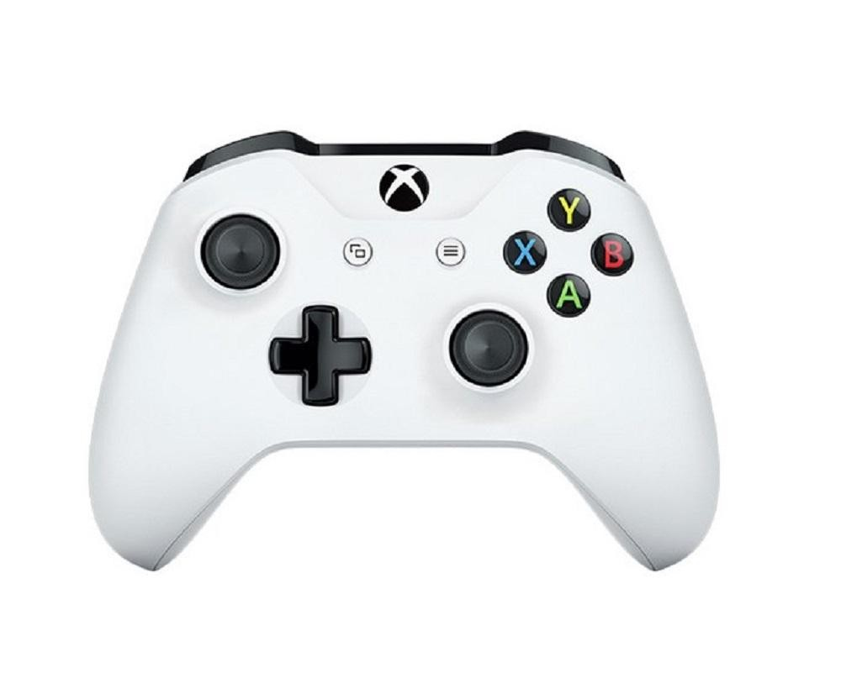

This effectively turns an Xbox gaming controller (Model 1708) into a keyboard interface capable of sending the values as follows:

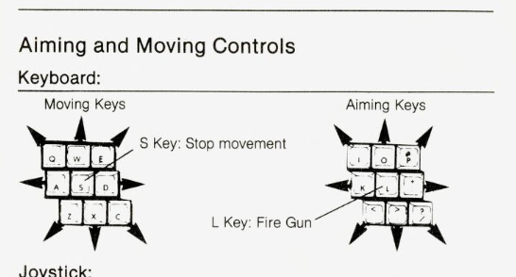

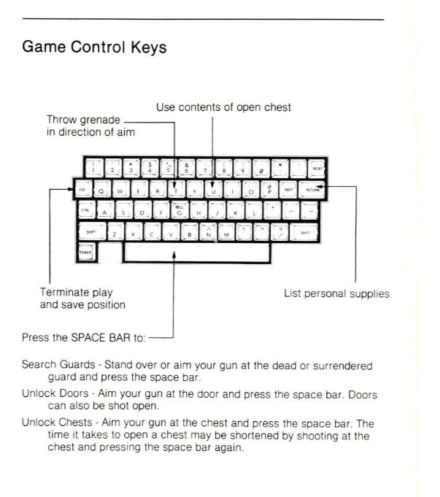

This connects in line with an Apple IIe keyboard and maps a Microsoft XBOX One S (Model 1708, firmware version 3.1.1221.0) controller (also works with 8BitDO running in XBOX mode X + Start) joystick values to keys.

If you need an Xbox controller, I search online for “Xbox 1708” will return many examples. This model supports ‘Classic Bluetooth’, newer models support Bluetooth LE.

**There are 3 Buttons on the RetroConnector board:**  
  1) Closed Apple  
  2) CTRL + Reset  
  3) Bluetooth Pairing - MUST BE DONE IN FIRST 5 SECONDS - Hold down the button to put the card into pairing mode.  You will see the Bluetooth Dongle light blink.  
 (after 5 seconds the card will attempt to connect to last pair/saved device)

**Xbox Analog Sticks**  
Left Analog does Movement - Center stops with 'S'

Right Analog does Gun Movement - Since Castle Wolfenstein doesn’t holster from keyboard, there is no way.  Beyond Castle will do (H)olster.

**Directionals (not used in Castle Wolfenstein, but for other games)**    Up / Down / Left / Right – Directional keys.  
  
**Buttons**    X - U for Use  
    A - Grenade throw  
    Y – Open Apple (Button 0)  
    B – Closed Apple (Button 1)

   L3 – Cycles through A-B-C-D (for Beyond Castle Wolfenstein when starting game)  
   R3 - CTRL-N - New game for starting the game.

   Left Trigger - Space for searching, opening, etc. items.  
   Right Trigger - Fires gun.

  Left Shoulder - K - for keyboard to start a game.  
   Right Shoulder - RETURN for Inventory

   MENU - ESC to exit game.  
   VIEW - Turns on repeating analog keys or nonrepeating analog keys.  In Castle Wolfenstein its much more responsive with nonrepeating keys. Default is nonrepeating.

Enjoy!

The firmware code is available on GitHub and can be modified to support any game mapping. To modify the mapping an Arduino AVR programmer is required to write onto the ATMEGA 328p chipset.